Renju lesson on December 14, 2000

Hello all! Nice to see you all here in renju class.
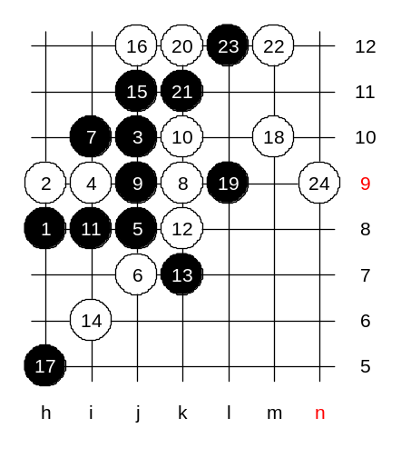
We will begin the lesson now. Today is probably the last lesson where we teach d3 opening. Next week I hope we can begin with another opening. We have studied three most important 5th moves already. Do you still remember them? True, j9, g9, i8 are the most popular 5th moves. We do not have time to study too much about one opening, therefore we will just learn one or two more 5th moves. Move 5-j8 used to be very popular move in the past. There are some choices for the 6th move. If you were white, where would you play the next move? There are three popular choices - i8, i7, j7. First, lets play j7. I tried this 6th move long time ago in important tournament against Bobkov (Russia). Bobkov played 7-i10. What is good style for white now? Yes, k9. I played actively and got the attack from the start. White attacks the forbidden 3x3 point. Maybe the 11th move is not so good. Let’s think about the white next (14th) move. How to continue attack in such situations? Let me explain some important technique of attack. White has very promising point L9, but it is good only if white gets the point j11 too. How is that possible? If white plays L9 then black plays a four to j11 and stops white three from m10. And if white plays directly to j11 then black takes the L9 point. The only way to make white plan work is to have a tempo to play both L9 and j11 so that black has no time to use the four. In such cases, the right move is i6. Now if black plays L9 then white plays four to h5 and then continues to i5 for example. And then white would win soon in lower side. So, we know that black has to block from h5. But before playing to h5, black should consider whether he has to use the four at j11 first or not. Lets see. If four first to j11 and then h5, then how can white win? tell me the moves. OK, lets play it, then you can see it easily.

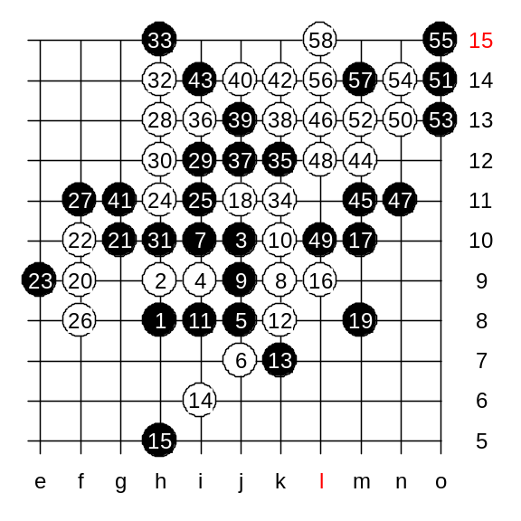
We saw that the black four to j11 caused black loss on previous diagram. Therefore black must play to h5 without using the four. Now, white can play L9 and j11. White tactics works. White got those two points he wanted. Now white has got very good position. White plays to f9 and increases the power. That move also connects sides. Crashingman asks, why 19-m8. The answer is: if 19-i12 then white plays k11, L11, L10 and wins. Lets continue. The following white moves are just one of the possibilities. Don’t consider them as 100% best moves - I am sure even the better moves can be found there. In my game with Bobkov, I played 24-h11. It is an attempt to connect left and right side. Move 26-f8 - a defensive preparation move. It eliminates black structures and then white can attack without worries. Now white played a series of attacking moves. Watch the diagonal overline. That is a trouble for black. White catches the overline. Now you see how big trouble can an overline be. The idea of m12 is to cook black's overline.

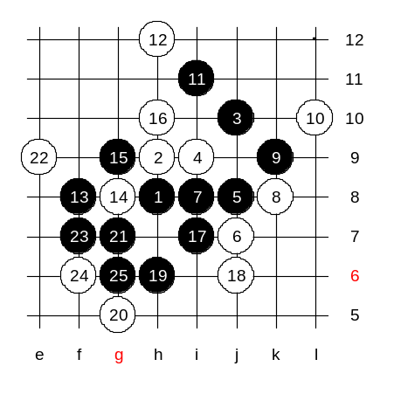
Lets see how black should play correctly in this variant. Move 7-i8 is the correct move. Next move - k9 is the key move. Now white is in trouble. No matter how white plays, black gets very powerful attack on either lower or upper side. Which white move do you want to try? I guess we play L10 then, thats the wish of most people here. Black has VCT.

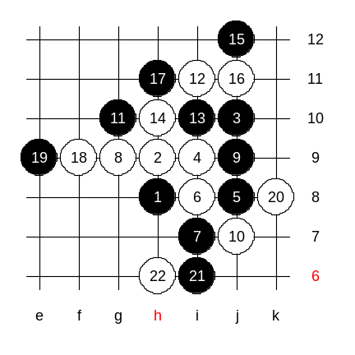
Now, lets look at another 6th move - i8. The following moves are a traditional theory. There are several 12th moves possible. I can just suggest some points - i11, i10, k9, etc. Lets play some moves in i11 path. White can either play 14-h10 or play a four to e9. Which way do we choose? ok, 14-h10. Black cannot attack in move 21. Black has to defend. And if defend, then the best is i6. Move i6 is the best defense because it breaks white connections between left and right side. White plays h6 now, and the outcome is quite balanced. Black has little advantage here. You think of 23-k6? Well, don’t become too passive, or you will never win any game. As white has nothing active on the right side, black can go and develop on the left side now. I just gave you the hint how and where to develop. Anyone can choose his own way to develop black attack on the left side. There are many good black moves - d8, e7, f8, etc.

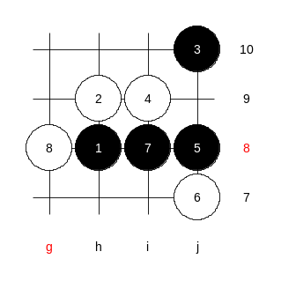

It is time for homework.
This is the medium level homework. Please find the black win.

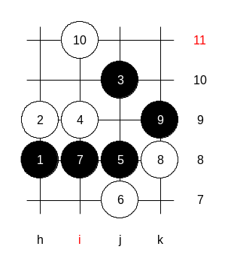

This is the advanced level homework. Please find black win.

